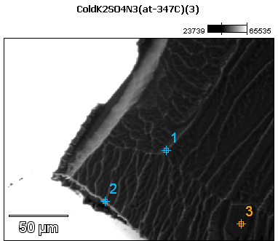

Image Name: ColdK2SO4N3(at-347C)(3)

Image Resolution: 512 by 384

Image Pixel Size: 0.45 µm

Acc. Voltage: 12.0 kV

Magnification: 550

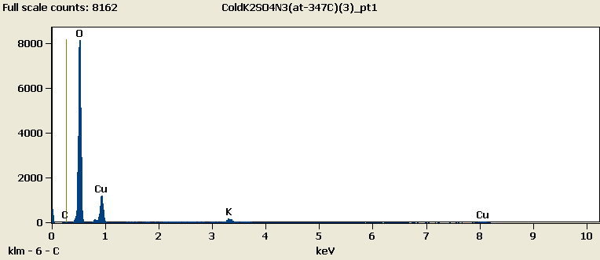

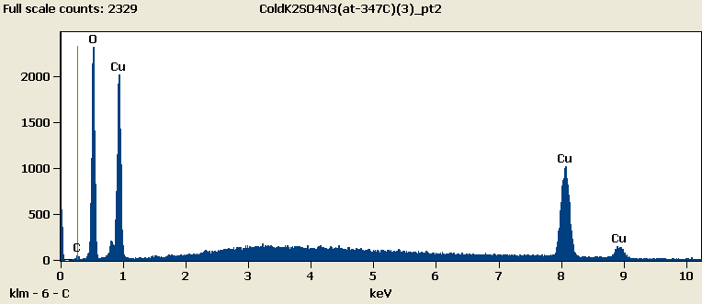

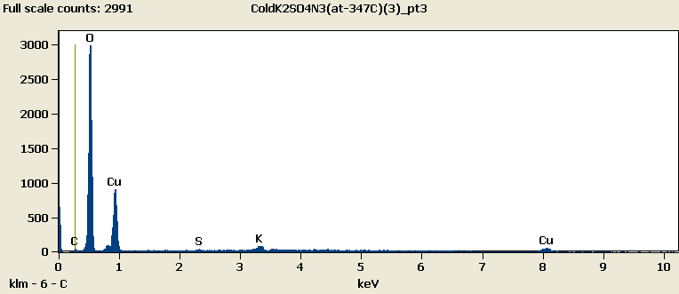

Weight %

|  |  |  |  |  |  |
| --- | --- | --- | --- | --- | --- |
|  | ***C-K*** | ***O-K*** | ***S-K*** | ***K-K*** | ***Cu-L*** |
| ***ColdK2SO4N3(at-347C)(3)_pt1*** | 0.38 | 65.87 |  | 3.19 | 30.57 |
| ***ColdK2SO4N3(at-347C)(3)_pt2*** | 2.30 | 35.47 |  |  | 62.23 |
| ***ColdK2SO4N3(at-347C)(3)_pt3*** | 1.31 | 53.85 | 0.48 | 2.46 | 41.90 |

Weight % Error (+/- 1 Sigma)

|  |  |  |  |  |  |
| --- | --- | --- | --- | --- | --- |
|  | ***C-K*** | ***O-K*** | ***S-K*** | ***K-K*** | ***Cu-L*** |
| ***ColdK2SO4N3(at-347C)(3)_pt1*** | ±0.12 | ±0.30 |  | ±0.11 | ±0.39 |
| ***ColdK2SO4N3(at-347C)(3)_pt2*** | ±0.23 | ±0.31 |  |  | ±0.60 |
| ***ColdK2SO4N3(at-347C)(3)_pt3*** | ±0.21 | ±0.38 | ±0.09 | ±0.34 | ±0.61 |

# Cations

|  |  |  |  |  |  |
| --- | --- | --- | --- | --- | --- |
|  | ***C-K*** | ***O-K*** | ***S-K*** | ***K-K*** | ***Cu-L*** |
| ***ColdK2SO4N3(at-347C)(3)_pt1*** | 0.00 | 0.00 |  | 0.00 | 0.00 |
| ***ColdK2SO4N3(at-347C)(3)_pt2*** | 0.00 | 0.00 |  |  | 0.00 |
| ***ColdK2SO4N3(at-347C)(3)_pt3*** | 0.00 | 0.00 | 0.00 | 0.00 | 0.00 |